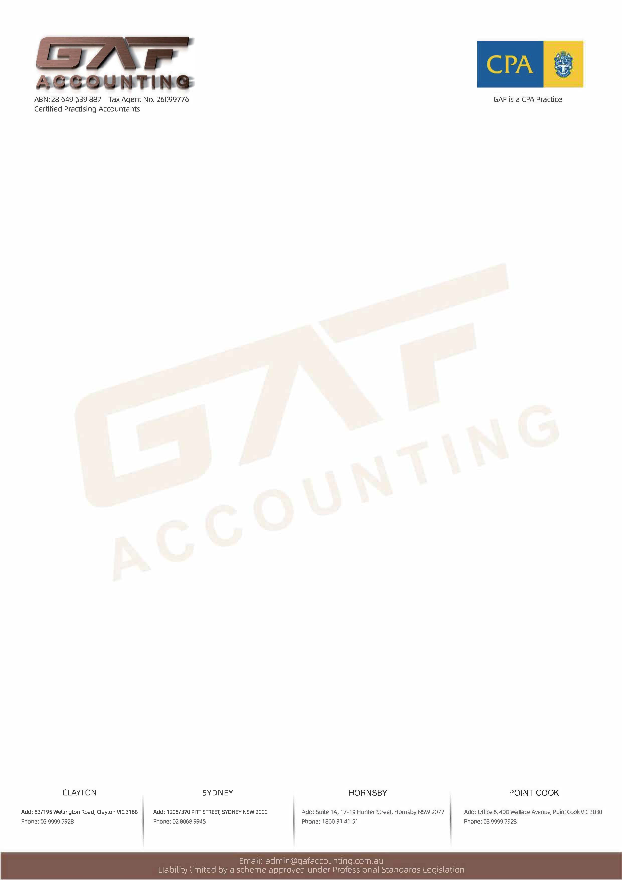

CHECKLIST – Self Managed Super Fund

The following checklist is a guide to help you provide all the documents necessary for us to complete your Fund’s ​(Which Year)_______ ____Financial Statements and Annual Return

Superfund Name: | Membership Name:
Address:
Contact Details: | Email:
Information Belongs to:
Bank/Cash Accounts:

1 | Bank statements for the full financial year |  |  |  | ​​ Choose an Item
2 | Term deposit notices for the full financial year including annual statement |  |  |  | ​​ Choose an Item
Any Comments |  | ​​☐​ | ​​Click or tap here to enter text.​

Shares:
3 | Report showing total shares owned by the Fund at |  |  |  | ​​ Choose an Item
4 | Buy/Sell contracts for shares purchased or sold during the year |  |  |  | ​​ Choose an Item
5 | Dividend statements |  |  |  | ​​ Choose an Item
6 | Current Chess Holding statements |  |  |  | ​​ Choose an Item
7 | For unlisted unit trusts copies of 2016 financial statements & 2016 tax return |  |  |  | ​​ Choose an Item
Any Comments |  | ​​☐​ | ​​Click or tap here to enter text.​

Trusts/Managed Funds:
8 | Transaction statements (usually quarterly) |  |  |  | ​​ Choose an Item
9 | Annual taxation statements |  |  |  | ​​ Choose an Item
10 | For unlisted unit trusts copies of financial statements & -/-/-/-_f.y. tax return
Any Comments |  | ​​☐​ | ​​Click or tap here to enter text.​

Properties:
11 | Current lease agreement | y | ​​ Choose an Item
12. | Real estate agent’s monthly and or annual statements | y | ​​ Choose an Item
13. | Insurance policy documents | y | ​​ Choose an Item
14. | Current market valuation |  | ​​ Choose an Item

Other:
15. | -Cashbooks/Spreadsheets/Data File |  | ​​ Choose an Item
16. | Loan agreements |  | ​​ Choose an Item
17. | Debenture statements (DOH/Momentum/Hastings Capital etc.) |  | ​​ Choose an Item
18. | Contribution reconciliations |  | ​​ Choose an Item
19. | Pension reconciliations
20. | Current investment strategy
21. | Life insurance policy documents

Signed:
Dated (DD/MM/YYYY):

