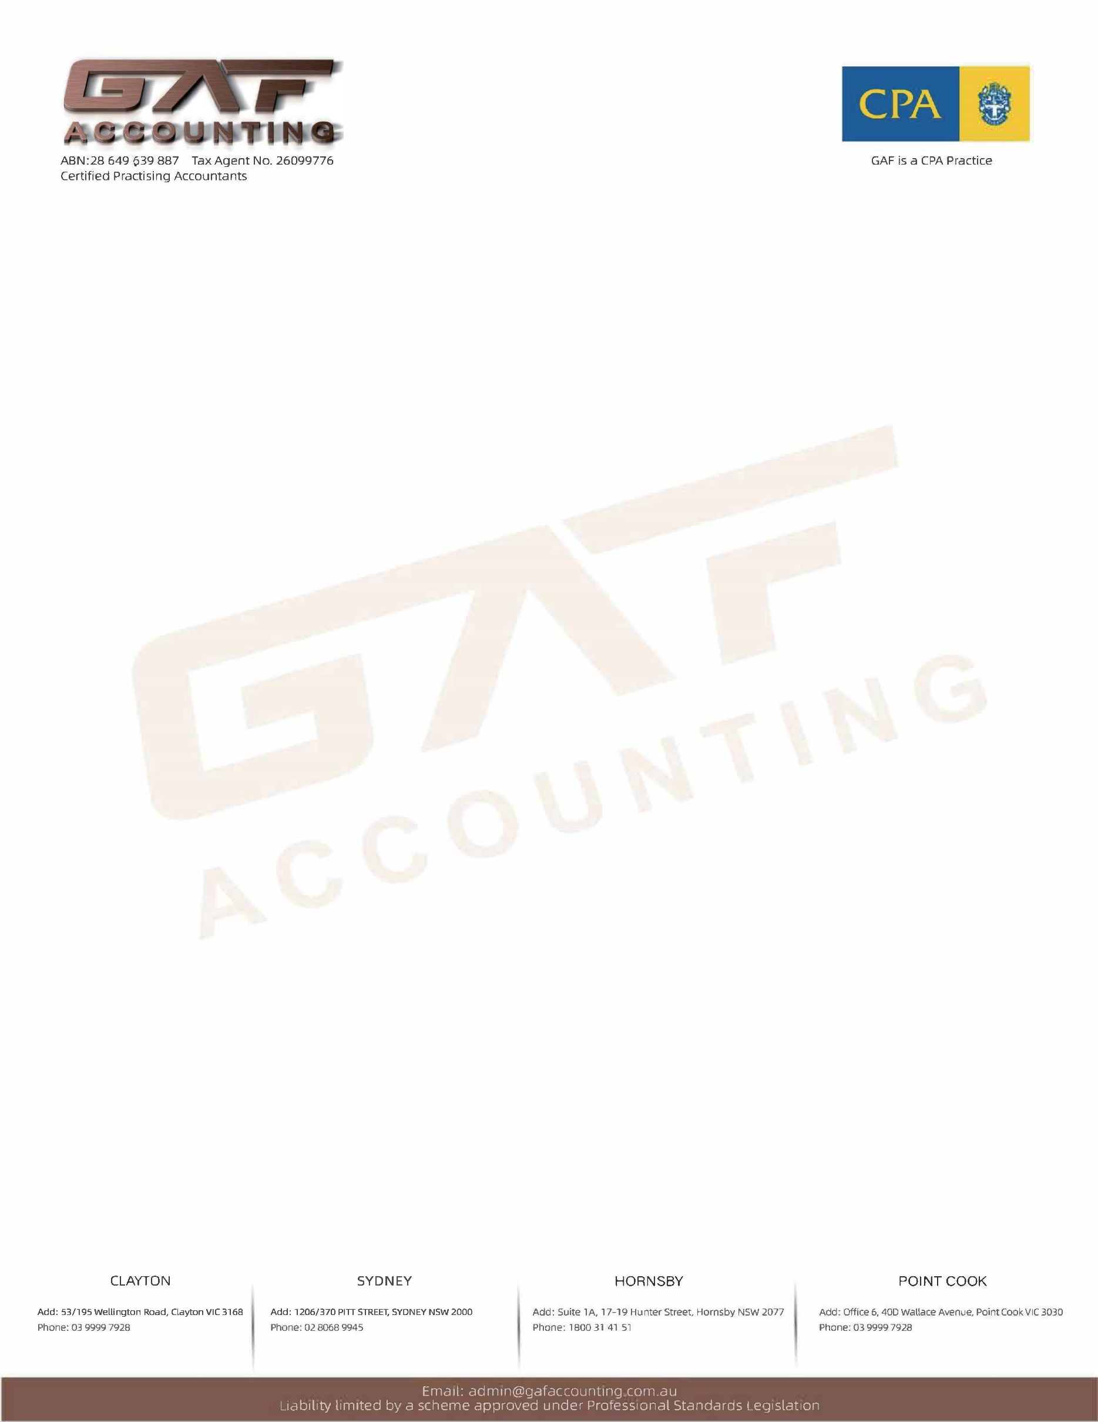

**Checklist - Business Activity Statement (BAS)**A BAS (Business Activity Statement) checklist is typically used by businesses in Australia to ensure they are fulfilling their tax obligations, specifically for GST (Goods and Services Tax), PAYG (Pay As You Go) withholding, and other relevant taxes. Here's a basic checklist to help you with BAS preparation:

|  |  |
| --- | --- |
| Contact Name: | Business Name: |
| Business Address: | |
| ABN (Australian Business Number) : | TFN (Tax File Number): |
| Contact Details: | Email Address: |
| Information Belongs to: | **Choose an Item** |

**Business Details:**

**Documents for BAS Preparation:**  
**Backup of Data Files:**

|  |  |  |
| --- | --- | --- |
| 1. Please provide a backup or export of your data file | | **Choose an Item** |
| Accounting Software:  **Choose an Item**  **Other:** | Version number of the software: | Login & Password details (If required): |
| 1. **Bank Statements:**   **Copies of all bank statements** showing **opening and closing balances** for the quarter. | | **Choose an Item** |
| 1. **Invoices for Income:**  Provide **copies of all invoices issued** to customers for the period, organized in **date order**. | | **Choose an Item** |
| 1. Payment Receipts for Purchases: Provide **copies of all payment receipts** for expenses (including purchases and asset acquisitions), in **date order**. | | **Choose an Item** |
| 1. Loan Schedule: Provide a **loan schedule** if applicable (e.g., business loans, vehicle finance, equipment leases, etc.). | | **Choose an Item** |
| **Additional Comments/Notes:** | | |

**Please note**: If the information provided is insufficient, we may request additional documents or details. Providing accurate and complete information will ensure the BAS preparation is efficient and correct, helping you meet your obligations and avoid delays.